LAB ASSIGNMENT 1

Author: Avasarala Ratnavalli Class ID: 5

Objective: To implement basic python codes

Features: Main features of the assignment are to get hands on in implementing:

1. Lists
2. Tuples
3. Loops
4. Functions

Configuration: The programs are implemented in pycharm with version 3.6

Programs

1)CODE and OUTPUT:

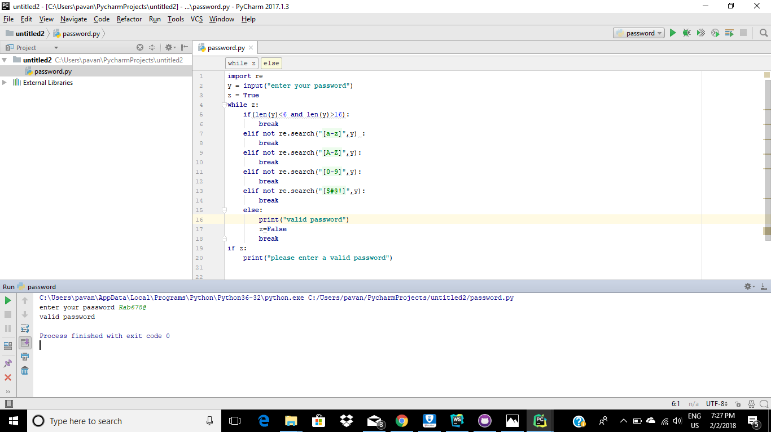

2)

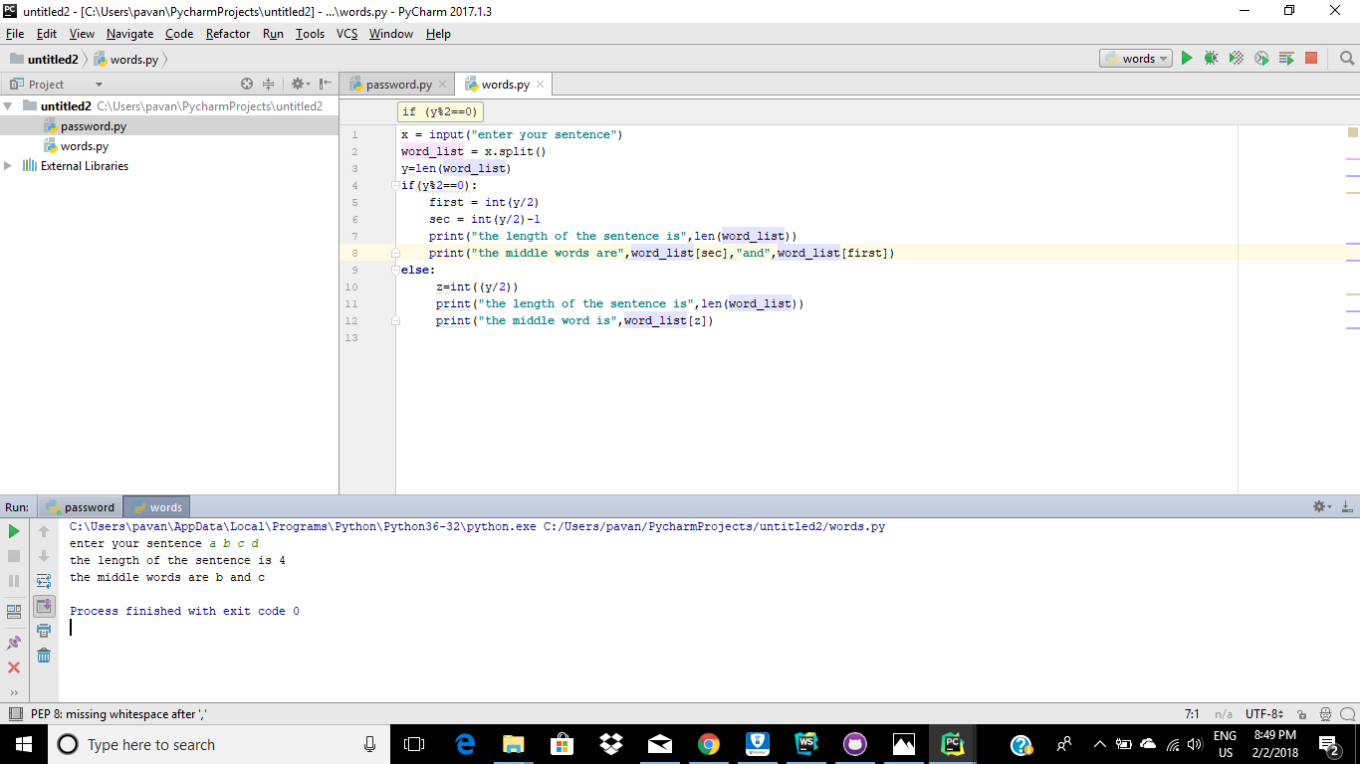

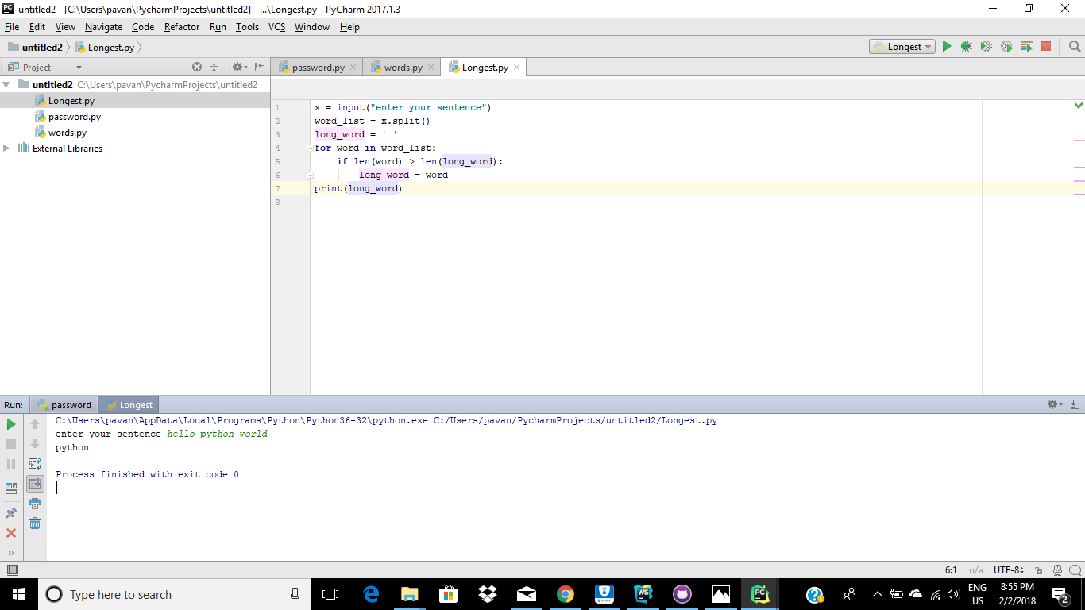

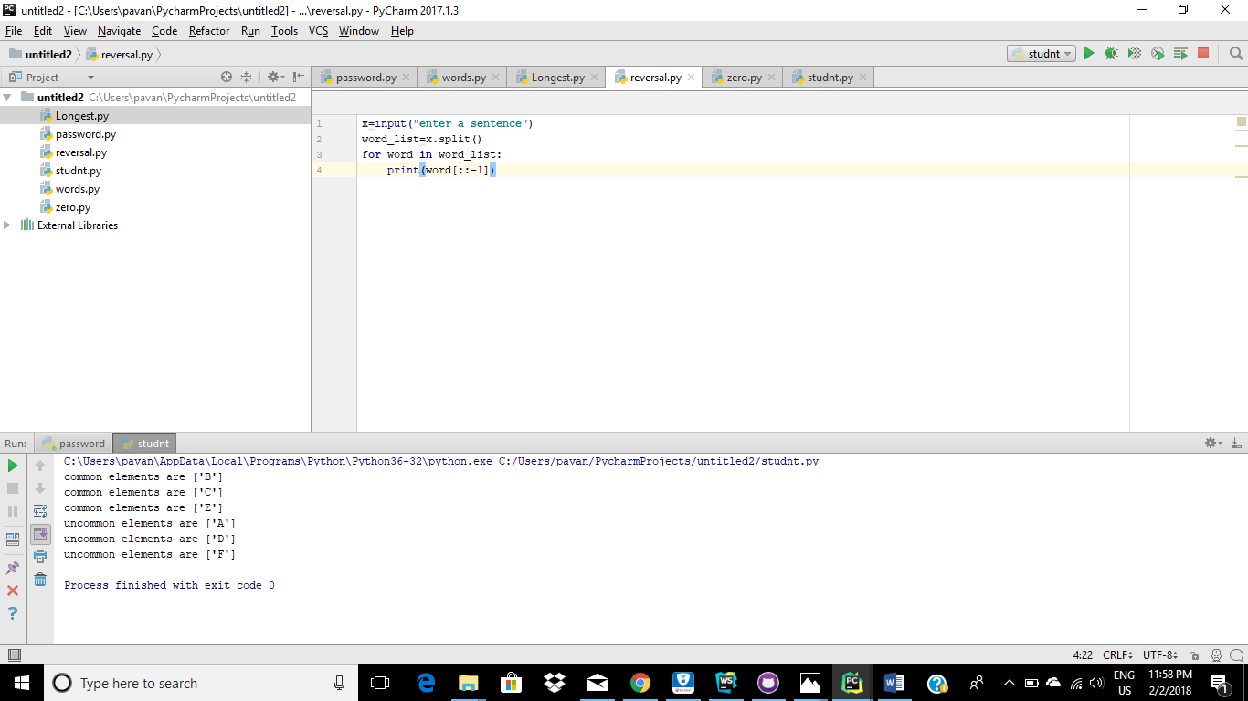

3)

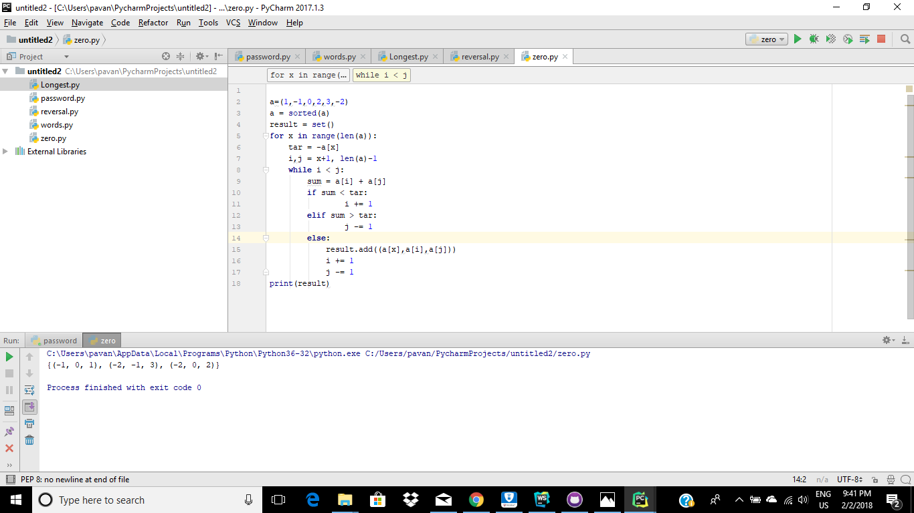

4)

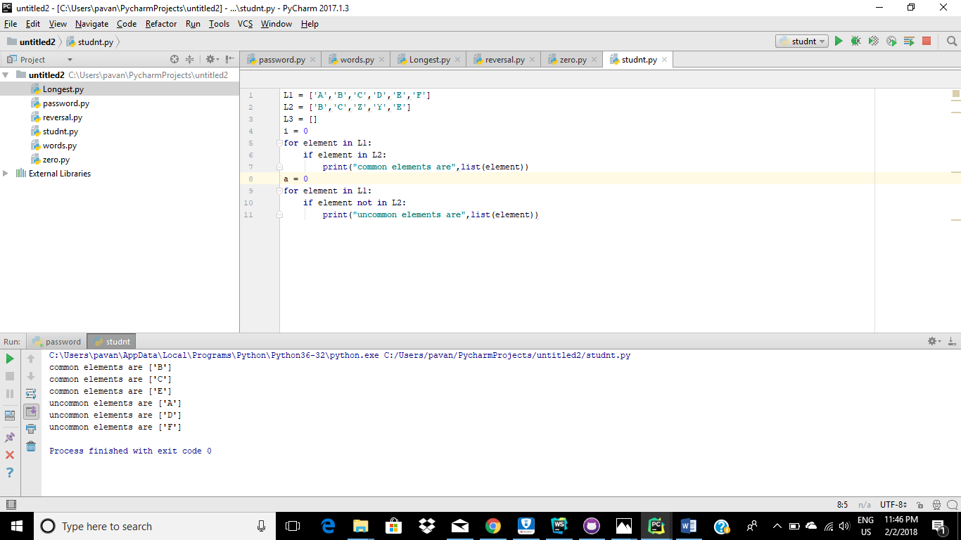

Deployment:

The code is run on pycharm platform.

References:

<https://stackoverflow.com/questions/16312730/comparing-two-lists-and-only-printing-the-differences-xoring-two-lists>

<https://stackoverflow.com/questions>

<https://geeksforgeeks.com>

<https://w3schools.com>